Communism: A History of Repression,
Violence, and Victims

Chapter 3 Assessments and Assignments

Create the Context Homework or pre-class preparation activity:
- Have students read the chapter essay and story, “Communism and Religion,” with a focus on why communist regimes worked so hard to destroy religion.
- Have students watch the videos listed below as a primer on the treatment of religion in communist countries.
  - The Chinese Communist Party is Erasing Muslim Identity (1 minute) https://youtu.be/dDrdjL0bkrM
  - The History of Christian Persecution in the Soviet Union (4 minutes) https://youtu.be/D0XSw3uMKWk
  - Persecution of Christians in the time of Communism in Russia (7 minutes) https://youtu.be/iS15xN0tNtM
Wrap-up Questions
- Why did the Communists seek to suppress or eliminate religion?
- What methods did the Communists use to remove religion from society?
- How and where is religious persecution still used today?

Assessments
- In-Class Assessment 1: Scenario Have students create a skit with different scenarios: people practicing their faith in private, what happens if faith is found out, how a person in leadership might act, a communist leader is secretly Christian or a Uyghur in China today.
- In-Class Assessment 2: Discuss Communist dictators sought to eliminate religion because the ideas of faith, hope, and love directly contradict and severely undermine the foundation of communist ideology. Have students discuss things they are passionate about (religion as an example, but they could also talk about activities, extracurricular groups, other beliefs, family etc.) and have them imagine what it would be like if their specific group was targeted simply for existing. Would they continue to seek out their passions and stay in the persecuted group? How would they feel if they were attacked because they belonged to a certain (religious or other) type of group?
- Take-Home Assessment Have students find a current news article or video about modern religious persecution in communist countries. Write a summary response paragraph on the news source discussing the background of the persecution and how it relates to this chapter.
Primary Source Activity
- Primary Source Activity: Analyze Have students read the field report. Ask them to analyze how the communists used religion to further their own ideals. What steps did the communists take to ensure religion was not a threat to their power?
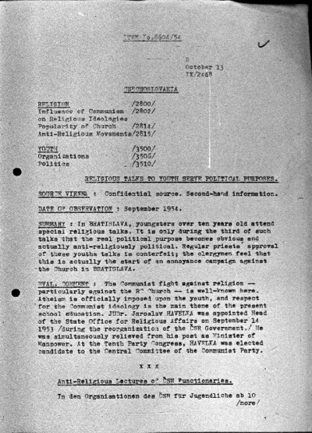
Primary Source
Religious Talks to Youth Serve Political Purposes

Religious Talks to Youth Serve Political Purposes, photograph, Europeana, accessed June 30, 2022, https://www.europeana.eu/en/item/2022043/10891_osa_6bac6869_8e50_4e14_8c7f_6a8eb46432d5.

