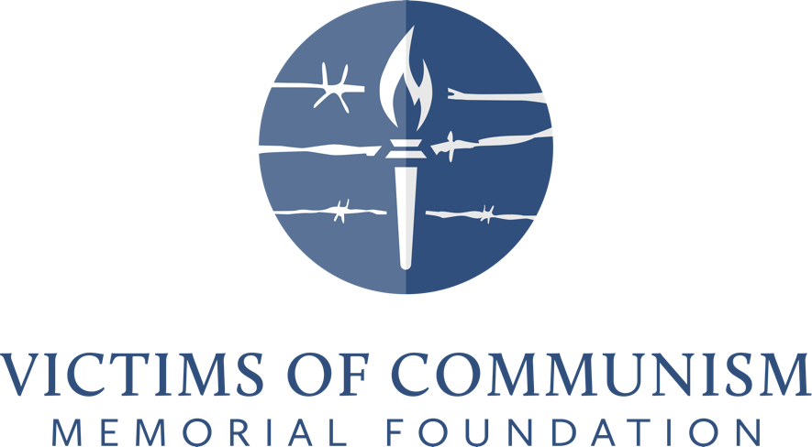

Communism: A History of Repression,
Violence, and Victims

Chapter 1 Assessments and Assignments

Create the Context Homework or pre-class preparation activity:
- Have students read the chapter essay and story, Communism 101, with a particular focus on the Bill of Rights and Marx and Engels’ 10 measures.
- Have students conduct a glossary review of the key terms used throughout the curriculum.
- Have students review the concept of rights as guaranteed in the U.S. founding documents.
- Have students watch the videos listed below as a primer on what communism is and where is it still practiced.
  - Communism will Always be Violent (3 minutes) https://youtu.be/Xuorv91vCVo
  - These are the Last Five Communist Countries (2016) https://www.youtube.com/watch?v=goUBuAWO7Xc.

Wrap up Questions
- Why is violence a central component to communism as outlined by Karl Marx and Friedrich Engels in the Communist Manifesto?
- The tragedy of communism is that it promises a utopia, but this never becomes a reality. Why? Consider the consequences of a monopoly of power by a totalitarian leader and a fearsome security apparatus.
- Which five countries are still under communist rule today?
- Explain how the Berlin Wall represented both a physical and ideological separation.
- How many deaths are attributed to communism since its inception in 1917?
Assessments
- In-Class Assessment 1: Discuss Have students discuss what it would be like to live in a country where the government controls every aspect of your life. How would their lives change?
- In-Class Assessment 2: Reenact Tell one student (or a small group of students) that they have to take a practice quiz. They are the only ones who must take the quiz, but then tell them that every other student in the class gets an A on the practice quiz even though they did not do the work for it. Discuss the fairness or equity of such a system when applied to other more serious aspects of life.
- Take-Home Assessment
Answer the following questions:
  - What are the differences between the U.S. Bill of Rights’ 10 specified rights and the Communist Manifesto’s 10 measures to achieve communism?
  - What is communism?
  - What is the most common form of communism called?
  - What is the strongest criticism of communism?

Primary Source Activity
- Primary Source Activity: Compare Have cut-out sheets with the rights specified in the U.S. Constitution’s first 10 amendments known as the Bill of Rights and the 10 measures specified in the Manifesto to achieve communism. Cut all the slots apart and mix up the lines of paper. Have students determine which phrases are in the Bill of Rights and which phrases are in the Communist Manifesto. Bonus points may be awarded if students put the phrases in the correct order.
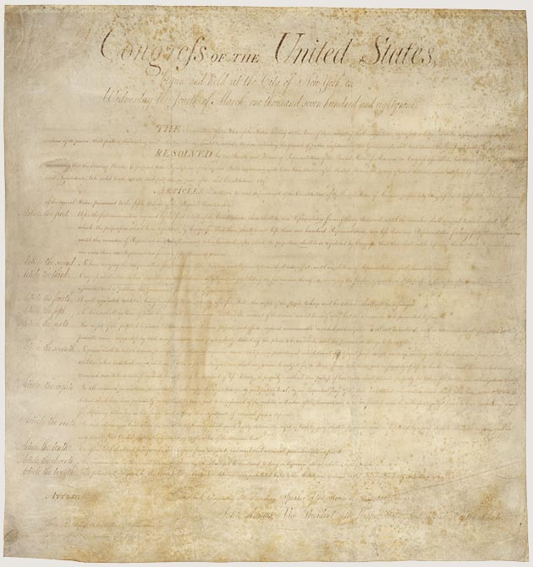

The Bill of Rights ratified in December 1791 lists 10 statements on natural rights, civil rights, and individual liberty.
1.Congress shall make no law respecting an establishment of religion, or prohibiting the free exercise thereof; or abridging the freedom of speech, or of the press; or the right of the people peaceably to assemble, and to petition the Government for a redress of grievances. 2. A well-regulated Militia, being necessary to the security of a free State, the right of the people to keep and bear Arms, shall not be infringed. 3. No Soldier shall, in time of peace be quartered in any house, without the consent of the Owner, nor in time of war, but in a manner to be prescribed by law. 4. The right of the people to be secure in their persons, houses, papers, and effects, against unreasonable searches and seizures, shall not be violated, and no Warrants shall issue, but upon probable cause, supported by Oath or affirmation, and particularly describing the place to be searched, and the persons or things to be seized. 5.No person shall be held to answer for a capital, or otherwise infamous crime, unless on a presentment or indictment of a Grand Jury, except in cases arising in the land or naval forces, or in the Militia, when in actual service in time of War or public danger; nor shall any person be subject for the same offence to be twice put in jeopardy of life or limb; nor shall be compelled in any criminal case to be a witness against himself, nor be deprived of life, liberty, or property, without due process of law; nor shall private property be taken for public use, without just compensation. 6. In all criminal prosecutions, the accused shall enjoy the right to a speedy and public trial, by an impartial jury of the State and district wherein the crime shall have been committed, which district shall have been previously ascertained by law, and to be informed of the nature and cause of the accusation; to be confronted with the witnesses against him; to have compulsory process for obtaining witnesses in his favor, and to have the Assistance of Counsel for his defense. 7. In Suits at common law, where the value in controversy shall exceed twenty dollars, the right of trial by jury shall be preserved, and no fact tried by a jury, shall be otherwise re-examined in any Court of the United States, than according to the rules of the common law. 8. Excessive bail shall not be required, nor excessive fines imposed, nor cruel and unusual punishments inflicted. 9. The enumeration in the Constitution, of certain rights, shall not be construed to deny or disparage others retained by the people. 10. The powers not delegated to the United States by the Constitution, nor prohibited by it to the States, are reserved to the States respectively, or to the people.
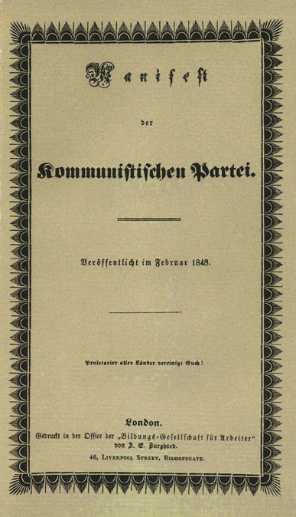

Communist Manifesto’s 10 Measures to Achieve Communism
1. Abolition of property in land and application of all rents
of land to public purposes. 2. A heavy progressive or graduated income tax. 3. Abolition of all right of inheritance. 4. Confiscation of the property of all emigrants and rebels. 5. Centralisation of credit in the hands of the State, by means
of a national bank with State capital and an exclusive
monopoly. 6. Centralisation of the means of communication and transport
in the hands of the State. 7. Extension of factories and instruments of production owned by
the State; the bringing into cultivation of wastelands, and
the improvement of the soil generally in accordance with a
common plan. 8. Equal liability of all to labour. Establishment of
industrial armies, especially for agriculture. 9. Combination of agriculture with manufacturing industries;
gradual abolition of the distinction between town and
country, by a more equable distribution of the population
over the country. 10. Free education for all children in public schools.
Abolition of children's factory labour in its present form.
Combination of education with industrial production, &c., &c.”

The Bill of Rights, U.S. National Archives, photograph, accessed June 29, 2022, https://www.archives.gov/founding-docs/bill-of-rights?_ga=2.70850640.1575451584.1654179819-1941961816.1653848673 and “The Bill of Rights: What Does it Say?”, U.S. National Archives, accessed June 29, 2022, https://www.archives.gov/founding-docs/bill-of-rights/what-does-it-say.
Public Domain, The Communist Manifesto, photograph, Encyclopedia Britannica, accessed June 29, 2022, https://www.britannica.com/topic/The-Communist-Manifesto/images-videos#Images and “The Communist Manifesto by Karl Marx and Friedrich Engels,” Full Text Archive, accessed June 29, 2022, https://www.fulltextarchive.com/page/The-Communist-Manifesto/.

